Horizontal Bar Chart

Definition
# Source: AI Source: Provided by: [Data Path: Persons Table -> ID Column: 1, Name_En Column: Motasem Essam] -> From: [Chatgpt (GPT‑5 Mini)] on [12/10/2025]
A Horizontal Bar Chart is a type of bar chart where the bars extend horizontally to represent values for different categories. The length of each bar corresponds to the value it represents.

Key Idea
# Source: AI Source: Provided by: [Data Path: Persons Table -> ID Column: 1, Name_En Column: Motasem Essam] -> From: [Chatgpt (GPT‑5 Mini)] on [12/10/2025]
Horizontal bar charts are useful when category names are long or when you want to compare many categories. Categories are placed on the y-axis, and values are shown on the x-axis.

How It Works
# Source: AI Source: Provided by: [Data Path: Persons Table -> ID Column: 1, Name_En Column: Motasem Essam] -> From: [Chatgpt (GPT‑5 Mini)] on [12/10/2025]
- Place categories on the y-axis.
- Place numerical values on the x-axis.
- Draw horizontal bars whose length represents the value of each category.

Example
# Source: AI Source: Provided by: [Data Path: Persons Table -> ID Column: 1, Name_En Column: Motasem Essam] -> From: [Chatgpt (GPT‑5 Mini)] on [12/10/2025]
Dataset: Sales by Product
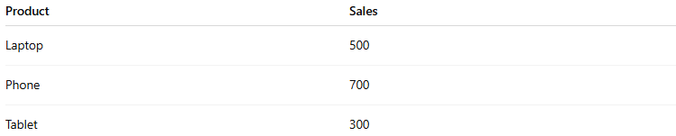
Product | Sales
Laptop | 500
Phone | 700
Tablet | 300
In a Horizontal Bar Chart:
- The y-axis shows products (Laptop, Phone, Tablet).
- The x-axis shows sales values.
- Each product has a horizontal bar whose length indicates sales.
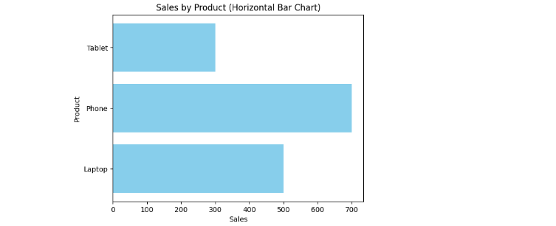

Applications
# Source: AI Source: Provided by: [Data Path: Persons Table -> ID Column: 1, Name_En Column: Motasem Essam] -> From: [Chatgpt (GPT‑5 Mini)] on [12/10/2025]
- Comparing categories with long labels
- Visualizing rankings (e.g., top-selling products)
- Displaying survey results
- Handling many categories without crowding the axis

Advantages
# Source: AI Source: Provided by: [Data Path: Persons Table -> ID Column: 1, Name_En Column: Motasem Essam] -> From: [Chatgpt (GPT‑5 Mini)] on [12/10/2025]
- Handles long category names better than vertical charts
- Easy to compare many categories
- Clear visual for ranked or ordered data

Disadvantages
# Source: AI Source: Provided by: [Data Path: Persons Table -> ID Column: 1, Name_En Column: Motasem Essam] -> From: [Chatgpt (GPT‑5 Mini)] on [12/10/2025]
- Less effective for showing trends over time
- May require more vertical space for many categories

